**ASSIGNMENTS ON DIGITAL MARKETING**

**NAME :** AKASH M

**DEPARTMENT :** BE COMPUTER SCIENCE

**COLLEGE :** 8151 DHANALAKSHMI SRINIVASAN INSTITUTE OF

TECHNOLOGY

**NAANMUDHALVAN COURSE**: DIGITAL MARKETING

**NM ID :** F6ACB566FDD386BA6D64A5B963020EE2

**ASSIGNMENT 1:**

Create a blog or website using Blogspot and WordPress. Customize

The theme design and post new article with 500 words.

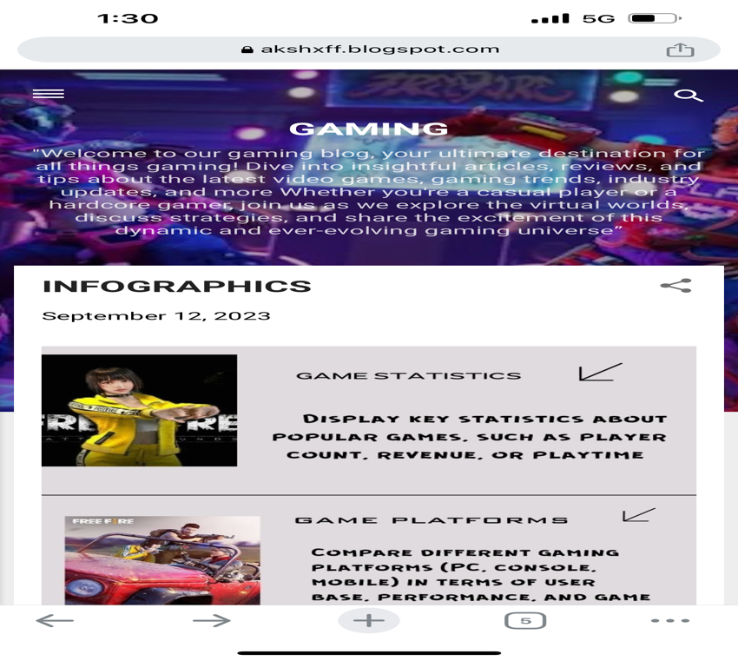 Blog : https://akshxff.blogspot.com/?m=1

**ASSIGNMENT 2:**

Create a new Facebook business Page and Post one social media poster for your brand.

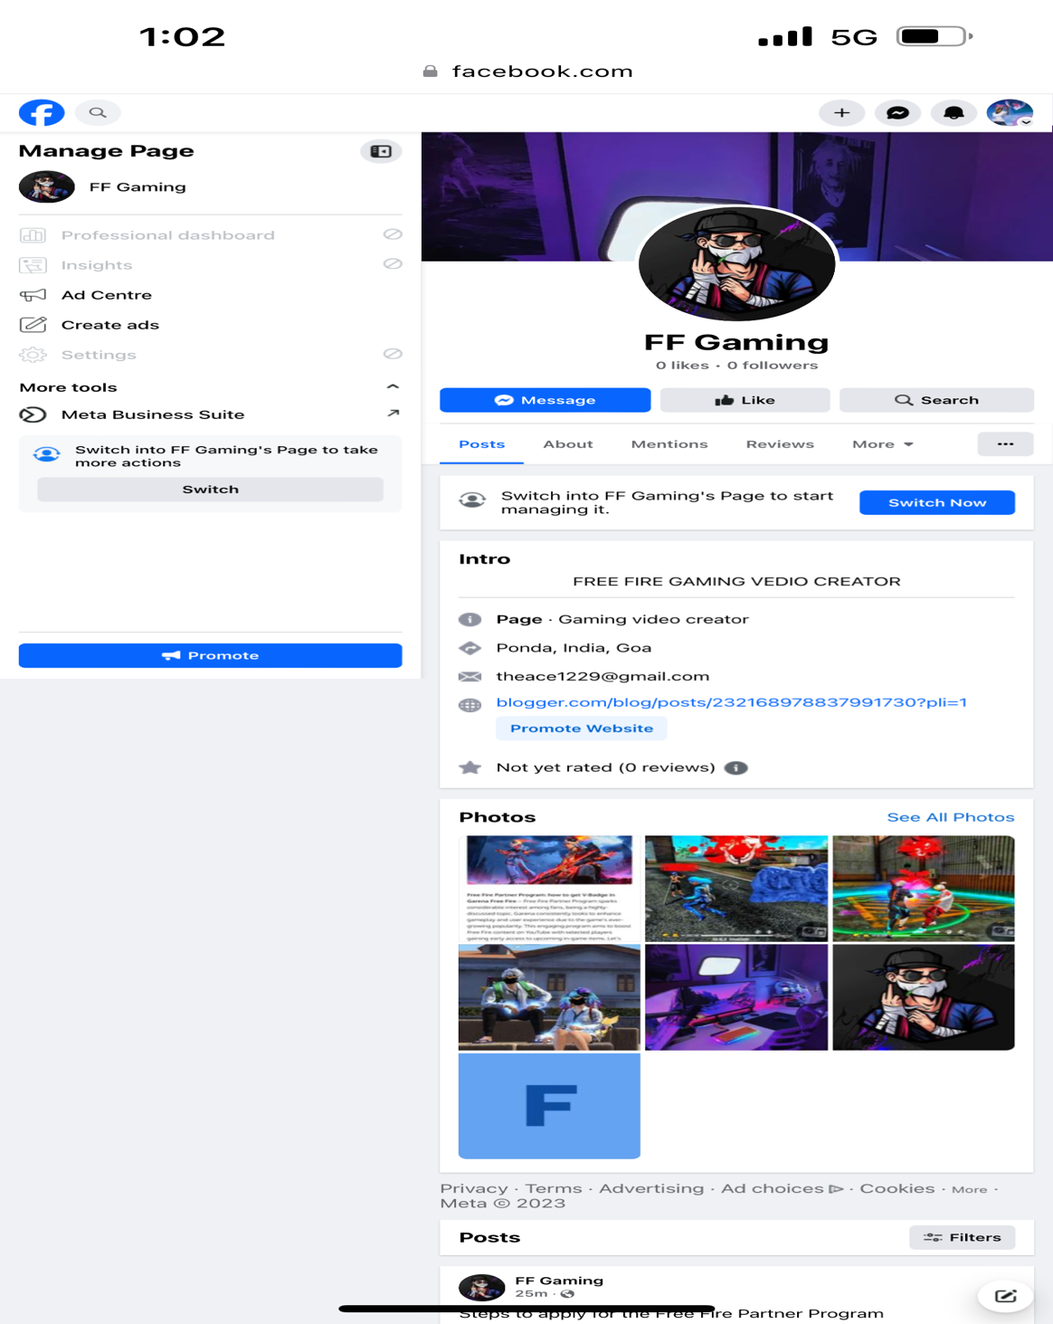https://www.facebook.com/profile.php?id=61552267777412&mibextid=LQQJ4d

**ASSIGNMENT 3:**

Create and design a social media advertisement poster using Canva.

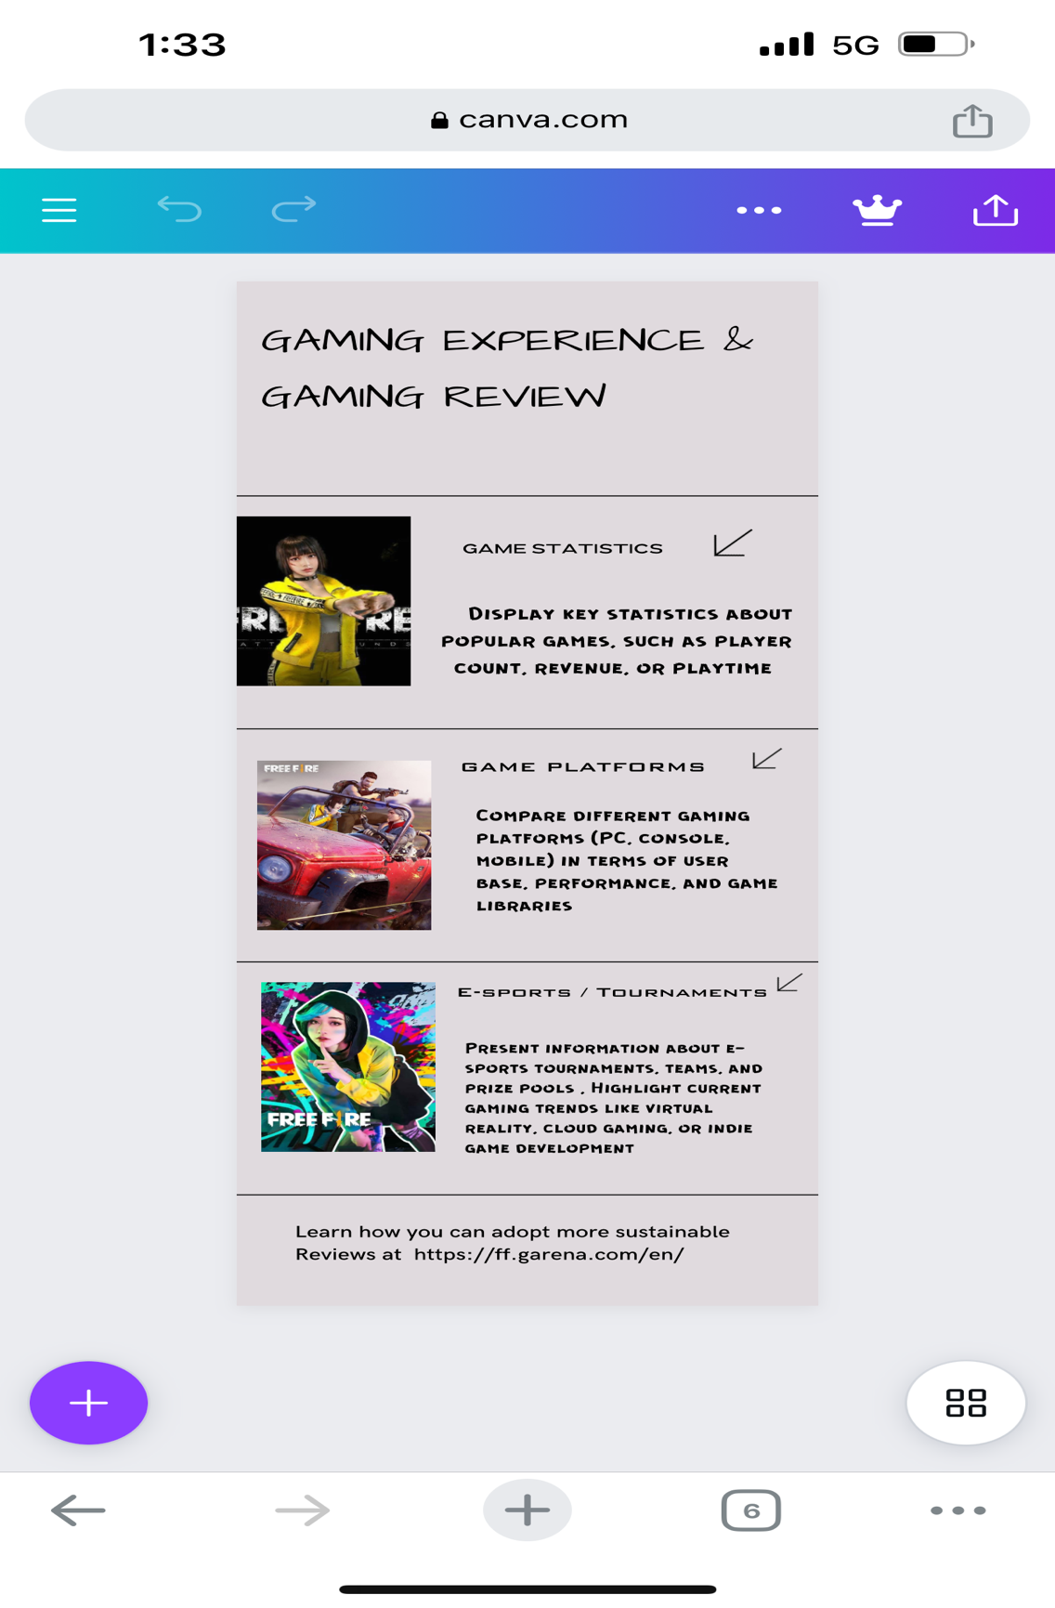

**ASSIGNMENT 4:**

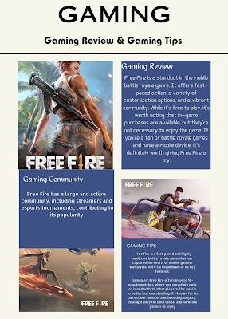4.Create email newsletter design using MailChimp or Canva tool.

https://akshxff.blogspot.com/2023/09/newsletter.html?m=1